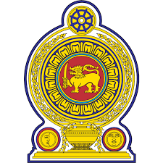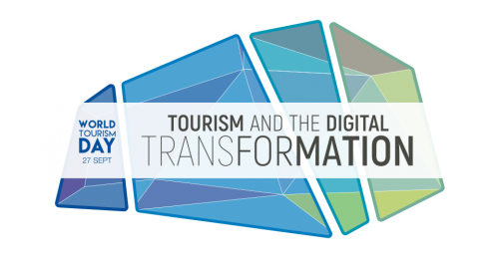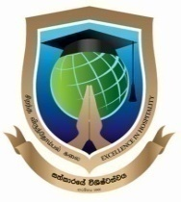

World Tourism Day -2018
“Tourism and the Digital Transformation”
Concept Paper
to conduct an inter school competition of SLITHM on innovative digital usage in tourism ,under the theme of “Digital Tourism and Sustainable Development Goals”
by
Tourism Club- SLITHM
Introduction:
Tourism has become a powerful too all over the world, connecting cultures, nations, and destinations, walking across the lives sustaining & prospering people in various ways. Tourism is contributing 10% of the world GDP and 1/10 of employment creation and 7% of the global exports .Considering with other industries tourism and hospitality brings huge potentials and opportunities to make a sustainable world. People, planet, prosperity and peace would not be a challenge if the tourism resources could be aligned in proper manner. However tourism is focusing an inclusive growth of people and society and environment.
Achieving sustainable development goals (SDGs) is the timely required factor and all efforts need to be focused with the same. Hence the possibility of tourism to meet those goals have become an undividable responsibility of its’ all stakeholders.
Sustainable Development Goals of United Nations:
- No Poverty 2.Zero Hungary
- Good Health & Well-being 4.Quality Education
- Gender Equality 6..Clean Water and Sanitation
- Affordable and Clean Energy 8. Decent Work and Economic Growth
- Industry, Innovation and Infrastructures
- Reduced Inequalities 11.Sustainable Cities and Communities
- Responsible Consumption and Production
- Climate Action 14. Life below Water
- Life on Land 16. Peace, Justice and Strong Institutions
- Partnerships for the Goals

United Nations has accepted the freedom of travel of people as a human right. Technological advancements are making a vital role in this regard. More ever, technology has invited to make sustainable approaches in life styles. Hence the future tourism industry will be relay on technological advancements. Importance of digital technology provides massive opportunities in tourism to make better travel experiences, transportation, tourism product marketing, tour guiding, hospitality services, tourism education, business opportunities, community development, and environmental sustainability.
Although, technological flat forms are utilized in the global context of tourism, it is not that much popular among Sri Lankan Tourism practices except few businesses such as online reservations, OTA, PMSs, reserving of transportation etc.
Hence there is a huge vacuum in digital utilization in tourism industry of Sri Lanka. Which could be introduced and provide advantages for many areas such as introducing and promoting tourist attractions, uplifting the travel experience, obtaining the satisfactory level of tourists, optimizing of operational & productivity of tourist establishments, effectiveness of the transportation, safety and occupational health, food hygiene etc.

Competition:
Theme of the Competition: “Digital Tourism and Sustainable Development Goals”
Tourism Club of SLITHM has identified its’ responsibility in making a platform for youngsters to come-up with their attractive and effective digital transformation ideas. Therefore the Institution is in a position to conduct a competition among all colleges with above focus. This was decided to amalgamate with the theme of World Tourism Day -2018: “Tourism and the Digital Transformation”.

Objectives of the Competition
- To make a broader Knowledge sharing platform for the innovative ideas and concepts in digital transformation for Sri Lanka Tourism
- Encourage, facilitate and recognize of youth of SLITHM and their creative ideas thro ‘ digital transformation
- Create awareness among general public and tourism professionals on usability and liking of digital technology in Tourism industry
- Establish responsible and sustainable tourism sector in Sri Lanka by digital advancements and usage

Way forward
- The competition is open for all SLITHM Colleges (groups and Individuals comprising students, academics and non-academics)
- Competition categories:
- Photography competition by Smart phones or any photographable device
- Creative E-flyer (based on a positive message on SDGs)
- Tourism Video Clips by smart phones( maximum 03-05 minutes)

- All the creations should be in line with Sustainable Development Goals mentioned above and theme or title should be suitable and related for tourism of Sri Lanka
- Particular digital creations should be innovative and should not be copied from any digital source
- Creations need to be certified by the Principal of respective SLITHM College and submitted on or before 12th October 2018
- Pls.Upload your creation/s to a preferred cloud storage service and email immediately the link/s and the application to digitaltourism@slithm.edu.lk
- One competitor /group can represent maximum 03 creations
- The digital creation will be presented to a panel comprised with ICT experts for evaluation and selection
- Cash prizes will be awarded for the winners as follows:
- First Prize - Rs.15,000/= (each category)
- Second Prize- Rs.10,000/= ( each category)
- Third Prize – Rs.7,500/= (each category)
- All the participants will be awarded a certificate at the certificate awarding ceremony
- Best creations will be utilized for promotional campaigns of SLITHM in future

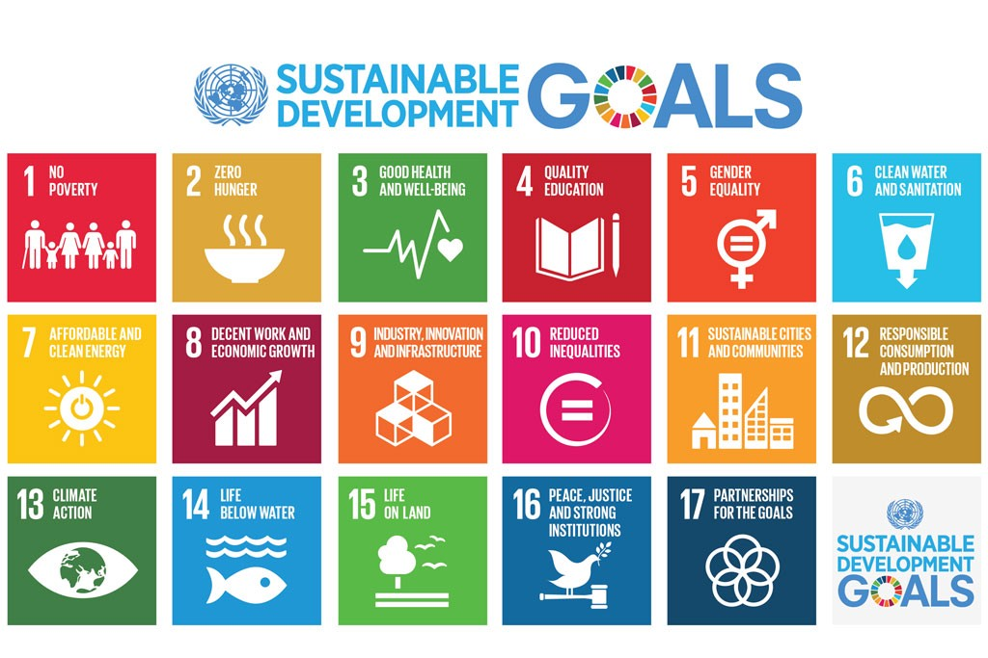

…………………………………………..

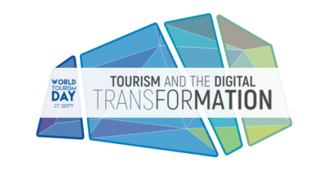

World Tourism Day -2018
“Digital Tourism and Sustainable Development Goals”
Digital competition organized by
Tourism Club- SLITHM
Application
- Name of the SLITHM College : :………………………………………………………………………………………………...............................................................................................................................................................................................................................
- Name with Initials (if Individual)
…………………………………………………………………………………………………………………...............................................
- Name of the Group:......................................................................................
- If representing as a group ,kindly attach the names of the group members along with the application and their classes/Departments
- Contact No:/s…… ……………………………………………………………………......................................................
- Email Address: :……………… ……………………………………………………………………...........................................
- Digital Concept/s in brief: ……………………………………………………………………………………………………............................................................
………………………………………………………………………………………………………………………………………………………………………………………………………………………....................................................................................................
I/we, declare that above information are true and accurate to best of my/our knowledge and hereby agree to the guidelines , rules and regulations of the competition. I/we certify the given digital idea/product is my/ours own creation and not copied from any source and published in any other forum previously.
Date:

Name/s & Signature/s:
1……………………………………………………………………………………………………
2……………………………………………………………………………………………………
3……………………………………………………………………………………………………
4……………………………………………………………………………………………………
5……………………………………………………………………………………………………

I certify that above Digital creation is developed by above mentioned member/members working/studying in the SLITHM Provincial College.............................................

Date:……………………… ………………………………..
Signature and the Name of the Principal of the College (with stamp)

